9th Annual EGA
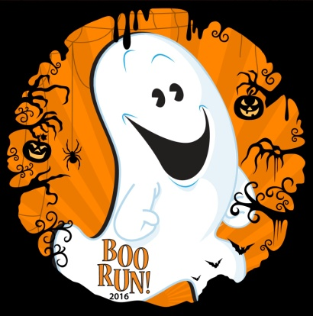
Boo Run 5K
Children’s One Mile Fun Run

Saturday, October 28,2017
San Gabriel Park
5K 9:00 AM start
Children’s One Mile Fun Run 10:00 AM start

Support our Georgetown-area children with developmental and intellectual disabilities by becoming a Titanium, Platinum, Gold, Silver, or Bronze Sponsor of the EGA Boo Run 5K / Children’s One Mile Fun Run

We invite you to join in this fun, community event to support this effort!
Sponsor Levels | Titanium($1500) | Platinum ($1000) | Gold ($750) | Silver ($300) | Bronze ($100)
Name or logo & acknowledgement located on front page of EGA website | √ | √ | √
Company name on Sponsor page of EGA website | √ | √ | √ | √ | √
Logo/Name on Event Banner: commit by 9/1 | √ | √ | √ | √ | √
Space to set up table for display of products & samples on race day | √ | √ | √ | √ | √
Company information/samples placed in runner’s bag | √ | √ | √ | √ | √
Company name on promotional materials (including t-shirt & brochure) commit by 9/1 | √  largest name or logo | √  name or logo | √  name or logo | √  Company name | Company name or family name on shirt only
Acknowledgment & public recognition on race day | √ | √ | √ | √ | √
Complimentary Race Entries | 6 | 4 | 2 | 2 Fun Run Registrations
The Exceptional Georgetown Alliance (EGA) exists to make everyday fun accessible to children with developmental and intellectual disabilities. Funding raised by the EGA helps support unique summer camps unavailable for our children in our area, plus sports teams ( basketball and baseball) and swimming lessons. The EGA also partners with other non-profit and for-profit organizations to make sure our community members with disabilities lead exceptional lives.

