Exceptional Georgetown Alliance
exceptionalgeorgetown@gmail.com

July 20, 2021
Dear Georgetown-area Business,
We are currently seeking sponsors for our 13th Annual EGA Boo Run scheduled for October 30th at the beautiful San Gabriel Park in Georgetown.
The Exceptional Georgetown Alliance (EGA) exists to make everyday fun accessible to children with developmental and intellectual disabilities. The EGA was formed by parents and educators in 2008 when funding for summer camps (that were being managed through the local school district) was no longer available. Because these camps are special to us, EGA members decided to take on the financial backing for the camps in conjunction with Georgetown Parks and Recreation.
Due to the special circumstances of many of our students, counselors for the EGA camps are typically Special Education teachers and paraprofessionals. Also due to the students’ unique needs, a low teacher to student ratio of 3 to 1 is typical for our adaptive summer camps. In addition to providing scholarships to children showing a financial need, the EGA helps to offset the operational costs so that the camp tuition for all children is more commensurate with the costs of typical day camps offered at the Rec Center. For several years now, we have donated ~ $9000 yearly towards these camps. We want to continue this level of monetary support, but we will need your help with a Boo Run sponsorship.
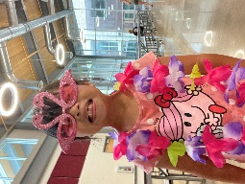 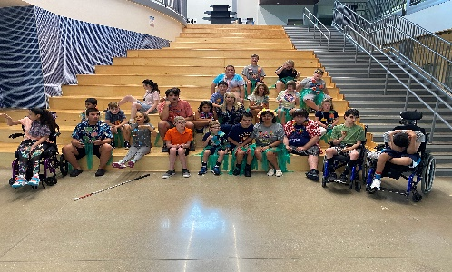 Campers in 2021 having fun!
EGA’s largest fundraiser is a 1mile/5K event that is held in late October and lovingly called the Boo Run. Boo Run 2021 will mark the thirteenth annual fund raiser for the EGA. Funds raised offset the cost of summer camps and help to fund other recreational activities in the Georgetown area for the following year.
We have partnered with many local organizations with the intention of bringing everyday fun within reach of those who need a helping hand. Besides the adaptive camps, the EGA sponsors local adaptive recreational activities including a baseball program, a basketball program, a swimming program, and a fall volleyball program.
The attached sheet lists the various Sponsorship Opportunities available for the 2021 EGA Boo Run. Your generous gift may be tax deductible. The EGA is a 501(c)(3) non-profit organization. Should you decide to donate, you may use the following tax-identification number (74-2786718). Thank you in advance for your support of the Exceptional Georgetown Alliance’s Boo Run!

