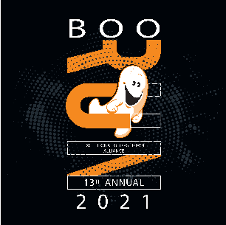
Exceptional Georgetown Alliance
13th Annual Boo Run
October 30, 2021
SPONSORSHIP

Level of Sponsorship: _____________________________________________________

DONOR

Item(s) Donated/Manner of Participation and Monetary Value of In-kind Donations.

_________________________________________________________________________

SPONSOR/DONOR INFORMATION

Please Circle One: Business Individual
Business or Individual’s name: ____________________________________________________________
Address: _____________________________________________________________________________
City, State, Zip Code:___________________________ Phone: __________________________________
Email: _____________________________________________ Fax: ______________________________
Contact Person(s), if Sponsor is a business
Contact 1 ____________________________________ Phone: __________________________________
Contact 2 ____________________________________ Phone: __________________________________

SOLICITOR (EGA/ Boo Run Committee Representative)

Name:________________________________________________________________________________
Phone: ______________________________________ Email: ___________________________________

PLEASE INCLUDE THIS FORM WITH YOUR SPONSORSHIP CHECK. Checks should be made payable to CTCF/EGA and mailed to:
4500 Williams Drive, suite 212-526, Georgetown, TX 78633

Sponsor Signature: _____________________________ Date: ___________________

